

Press Release for upcoming

event in multiple communities on 5 /20 / 21

Addressing Food Insecurity in North Atlanta

**Yes, even in Alpharetta, Dunwoody, Roswell and Sandy Springs**

**there are people who suffer from food insecurity. Food pantries and**

**nonprofits in these communities sometimes struggle to meet the needs of families.**

**The Rotary Club of Sandy Springs is coordinating a group effort with several Rotary Clubs to obtain one of the last deliveries of 1,100 food boxes from the USDA Farmers to Families Food Box program which is sunsetting on May 31, 2021.**

This program was designed and implemented as a temporary, emergency relief effort to respond to severe market disruption caused by a global pandemic. Since May of last year more than 155 million food boxes across the United States have been distributed feeding many families in need.

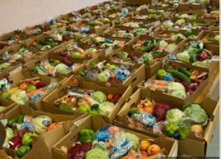**On Thursday morning May 20, 2021, many Rotarian volunteers will come together in Sandy Springs to unload a truckload of boxes and transfer them to multiple vehicles to deliver the boxes to food pantries & non profits in their communities. Later that day the volunteers will assist the pantries in storing and distributing the food to families in need.**

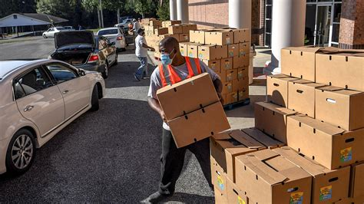 More info on the USDA program:

<https://www.ams.usda.gov/selling-food-to-usda/farmers-to-families-food-box>

Food boxes usually contain 30 lbs. of food: 12 lbs. fresh produce, 5 lb. meat, 5 lbs. of dairy and 1 gal. of milk.

OPPORTUNITIES FOR MEDIA COVERAGE:

**\* Scheduled USDA truck delivery: 7 am, May 20** Location**: Solidarity Sandy Springs**, loading dock,

(* Delivery time could vary) 5630 Roswell Road, Sandy Springs, 30342

Contact: Jennifer Barnes 404 271 1347

**Food Boxes Distribution:**

***Rotary Club of Sandy Springs* # Boxes Scheduled**

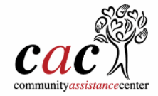

8607 Roswell Road, Sandy Springs GA 30350

Food Donation/Delivery Hours M–F, 9:30 a.m. – 3 p.m.

Contact: Gail.Pennington@ourcac.org

****<https://www.ourcac.org/> 100

5630 Roswell Road, Sandy Springs, GA 30342

Shopping times: Tues, Thurs., Sat. 9 am – 12 pm; Tue. 5-7 pm 150

<https://solidaritysandysprings.org/>



Acworth United Methodist Church 100

Contact: [kate@acworthumc.org](mailto:kate@acworthumc.org)

***Rotary Club of Dunwoody***

At [St. Patrick's Episcopal Church,](http://stpat.net/) 150

4755 North Peachtree Rd, Dunwoody, 30338

Food Distribution: Wednesdays 9 am - 12:30 pm

Contact: Judi Carlson malachis@stpat.net

***Rotary Club of Alpharetta***



3540 Keith Bridge Road, Cumming 30041

Food Distribution: Wednesdays 10 AM - 4 PM

Contact: [suelen.daniels@mealsbygrace.org](mailto:suelen.daniels@mealsbygrace.org) 100

***Rotary Club of Roswell*** 500

Many volunteers will be distributing boxes at the pkg. lot behind Roswell city hall on 5/20

to multiple non profits and families in Roswell including

Contact: Nancy Alterman [nanraa@bellsouth.net](mailto:nanraa@bellsouth.net)

770 262 6300



About Rotary and the Rotary Club of Sandy Springs:

## Rotary International is the largest service club organization in the world. Rotary is a global network of 35,000+ clubs with 1.2 million neighbors, friends, leaders, and problem-solvers who see a world where people unite and take action to create lasting change – across the globe, in our communities, and in ourselves.

## Solving real problems takes real commitment and vision. For more than 110 years, Rotary's people of action have used their passion, energy, and intelligence to take action on sustainable projects. From literacy and peace to water and health, we are always working to better our world, and we stay committed to the end.

Our Rotary Club consists of business and professional leaders in Sandy Springs. Working with business and government in our community the club has been meeting Rotary’s motto of “Service Above Self” for over 49 years with service projects benefiting school children, first responders, seniors and others. Meetings are held most Mondays at noon at the Hilton Perimeter Suites, 6120 Peachtree Dunwoody Rd., Sandy Springs 30328.

# For more information, press only:

PR Contact: Todd Lawrimore, Public Relations Officer

Phone: 404-435-4192

Email: [tlawrimore@gmail.com](mailto:tlawrimore@gmail.com)

Club President: John Neill, 678-472-1649, [jneill559@yahoo.com](mailto:jneill559@yahoo.com)

**Coordinator for this May 20 Food Box project**

# Additional information available at:

Website: sandyspringsrotary.org

Email: [sssrotary@gmail.com](mailto:sssrotary@gmail.com)

Address: P. O. Box 28894, Sandy Springs, GA 30358

Facebook RotaryClubofSandySprings

